Project Report

Author: Stavri Gkousi

Subject: CS 312 Database Management Systems

My fashion design company

As the topic of this project I have chosen to upgrade my fashion company used in the previous classes project. This fashion company is worldwide operational and it’s goal is to periodically prepare Summer and Winter collections, get orders and ship the goods to the customers.

This company has 40 freelancer employees, 6 collections, 12 products, 40 customers and has gotten 80 orders totalling at 150 items.

The freelancers are appointed to only one assignment. It shows that the company only hires people when needed on a project thus their payment is based on the assignments they partake and not on a monthly basis.

Each customer can have one or many orders and each order contains a multitude of products(items).The shipping process happens in two parts.

The inspiration for this project is the fact that for a long time I have been very interested in the fashion industry and with this project I have been able to gain an insight into how these companies work in real life. The database that I have developed can be very useful for people who occupy the position of CEO, directors, accountants or department managers.

A good use of these database is the fact that it can be very useful for automating systems like hiring policies with the help of trigger queries.

In this project we have a M-N relationship between the table’s orders and items. It contains a 1-1 relationship and a hierarchical relationship in the employee’s table. The hierarchical relationship is between the employee_id and managers. The queries I have made can be very useful in a real-life situation. The queries range in relation to the lessons we have done in class, they contain subqueries(correlated and non-correlated), hierarchical queries, PL/SQL procedures, functions and triggers. The queries can be used to filter, sort and display simple data we need. The PL/SQL queries are used to provide complex information, show database relations and create ways to trap errors so that our database can maintain its integrity.

TABLE DESCRIPTION

Table name: Employees

Employee_ID: shows a unique text that depicts each employee

Employee_Title: The title of the person depending on their gender(used to generate male or female names)

Employee_name: Displays the name of the employee

Employee_surname: Displays the surname of the employee

BirthDate: Shows the birthdays of the employees

Address: Displays the address of the employees

Phonenumber: Displays a form to contact the employees in this case a phone number

Bonus: a percentage value to be added to the payment they get from the project. This bonus isn’t specific because it is a negotiable value

Manager: Contains all the IDs of the managers of the company

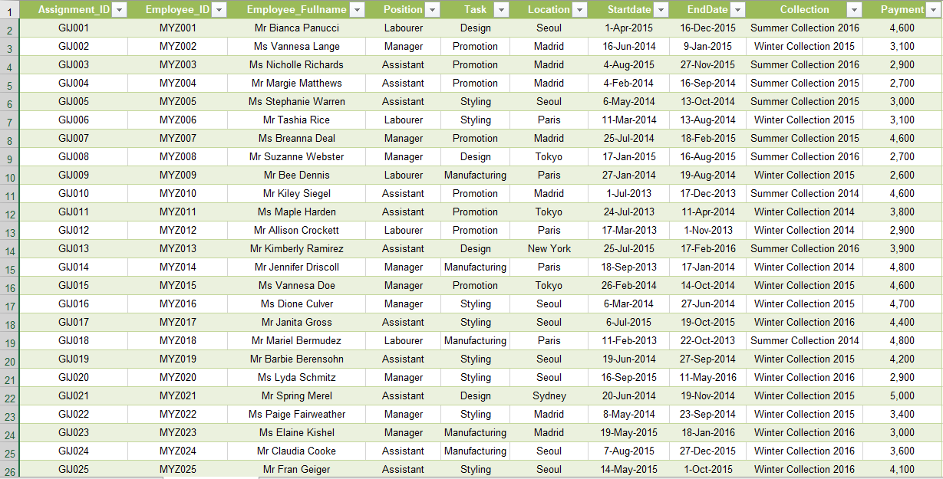

Table name: Assignments

Assignment_ID: a unique text to identify the assignments

Employee_ID: shows a unique text that depicts each employee to be used as a foreign key

Employee_Fullname: Displays the full name of the employees with their title

Position: The position an employee has on a project, this position can be Manager,Assistant, Labourer

Task: Shows the task the employee has worked on. This task can be Design, Styling, Manufacturing, and Promotion.

Location: Shows where the employee is currently working. Multiple employees can work on a project yet be in different cities in the world

Startdate: Displays the date when work started on a project. The data used is random but it is limited to a few months in the year because the company makes 2 collections in a year

EndDate: Displays the date when work on the project is finished. The date is randomized to always be bigger than the starting date yet it finished a few months before the collection is said to be released.

Collection: The project each employee was assigned to. The collection is created in the years 2014, 2015, 2016. The collection is made of the Summer and Winter collections.

Payment: The employee payment for the project. Payments aren’t attached to a position because workers might be in different locations.

Table name: Customers

Customer_ID: unique text to identify each customer

Title: the title related to the customer's gender

Firstname: The first name of the customer

Lastname: The last name of the customer

BirthDate: The birthdate of all the customers

Address: Displays the address of the customers

Phonenumber: Displays customer's way of communication in this case a phone number

Area: Displays the continent where a customer is located

Rank: A form of ranking priority-wise of customers. The ranks are Platinum, Gold, Silver, Bronze

Preferred_Paymnet: The preferred way a customer likesto pay. The types are Cash, Credit Card, Bank Wire

Table name: Products

Producst_ID: Unique text to identify a product

Name: The name of the product

Collection: The collection each employee was assigned to

Cost: The cost to make a product

Price:The price of a product

Table name: Orders

Order_ID: Unique text to identify orders

Customere_ID: unique text to identify each customer and used as a foreign key

Order_Date: The date when the order was made

Pay_Type: The method with which the payment was made

Order_Status: The status of the order

Cost_FirstShipment: How much the first shipment cost

Cost_SecondShipment: How much the second shipment cost

Table name: Items

Order_ID: Unique text to identify orders and used as a foreign key

Product_ID: unique text to identify each product and used as a foreign key

Total_Quantity: Shows the total quantity of products in an order

Quantity_FirstShipment: The quantity of products in the first shipment

Quantity_SecondShipment: The quantity of products in the second shipment

Queries

Querry1: Display the quantity of winter products during the month of January in descending order

select p.product_id product_id ,p.name name,sum(i.total_quantity) total_quantity

from products p,items i,orders o

where p.product_id=i.product_id and o.order_id=i.order_id and p.collection like 'Winter%'

and to_char(o.order_date,'MM')='01'

group by p.product_id, p.name

order by sum(i.total_quantity) desc

Querry 2: Display the employee's full name, birthdate, position, and collection they work on

select a.employee_fullname,e.birth_date,a.position,a.collection

from employees e,assignments a

where e.employee_id=a.employee_id

order by e.birth_date

Querry 3: Display the most populated positions

select count(assignment_id),task

from assignments

group by task

order by 1

Querry 4: Display the shipped orders where customers paid with their preferred payment type

select o.order_id order_ID, c.preferred_payment prefered_payment, o.pay_type payment_type

, o.order_status Order_status

from orders o join customers c

on o.customer_id = c.customer_id

and c.preferred_payment = o.pay_type

and o.order_status = 'Shipped'

order by o.order_id;

Querry 5: Display info for the customer who had the most amount shipped on the first shipment

create or replace view private as

select quantity_firstshipment quantity,order_id

from items

order by quantity_firstshipment desc

select c.*

from customers c,orders o

where o.customer_id=c.customer_id

and o.order_id=(

select order_id

from private

where rownum=1

)



Querry 6: Display the quantity of all the shipped items, order by date

select i.order_id||i.product_id orders,o.order_date dates,i.total_quantity

from orders o,items i

where o.order_id=i.order_id and o.order_status='Shipped'

order by o.order_date

Querry 7: Find the profit from product manufacturing for every customer area and sort in descending order

create or replace view profit_by_area as

select c.area "Customer Area", sum((p.price-p.cost)*i.total_quantity) "Manufacturing Profit"

from customers c join orders o

on c.customer_id = o.customer_id

join items i

on o.order_id = i.order_id

join products p

on p.product_id = i.product_id

group by c.area

order by c.area desc

select *

from profit_by_area

Querry 8: Find total profit from products

select sum("Manufacturing Profit") "Total Profits"

from profit_by_area;



Querry 9: Find the status of orders where the first shipment costs more than the second one, while it contains less quantity of products

select o.order_status,count(i.order_id) "Shipments"

from orders o,items i

where i.order_id=o.order_id and i.quantity_firstshipment<i.quantity_secondshipment

and o.cost_firstshipment>o.cost_secondshipment and o.order_status='Shipped'

group by o.order_status

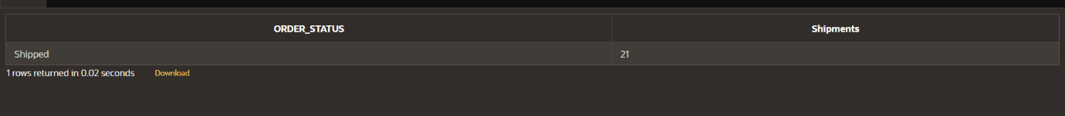

Querry 10:Find the profit from product manufacturing for every payment type

create or replace view payment_profit as

select o.pay_type "Payment Type", sum((p.price-p.cost)*i.total_quantity) "Manufacturing Profit"

from customers c join orders o

on c.customer_id = o.customer_id

join items i

on o.order_id = i.order_id

join products p

on p.product_id = i.product_id

group by o.pay_type

order by o.pay_type;

select *

from payment_profit;

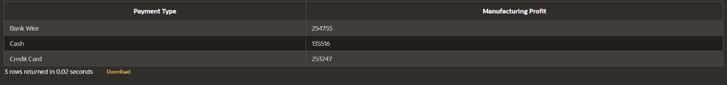

Querry 11: Show the quantity of every product ordered

create or replace view view_1 as

select product_id, name

from products

create or replace view view_2 as

select product_id,sum(total_quantity) quantity

from items

group by product_id

order by 1

select sum(decode(a.name,'Shirt',b.quantity)) "Shirt",

sum(decode(a.name,'Jacket',b.quantity)) "Jacket",

sum(decode(a.name,'Shoes',b.quantity)) "Shoes",

sum(decode(a.name,'Suits',b.quantity)) "Suits"

from view_1 a,view_2 b

where a.product_id=b.product_id



Querry 12 Employee with id: MYZ040 has left the company,delete useless record

create or replace procedure deletion(id_del in varchar2)

is

begin

delete from assignments

where employee_id=id_del;

delete from employees

where employee_id=id_del;

end deletion;

begin

deletion('MYZ040');

end;

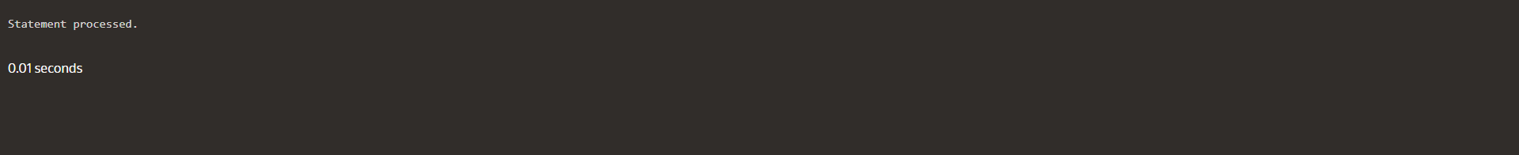

Querry 13 check condition if what we insert into employees is null

create or replace trigger emp_check_null

before insert on employees

for each row

declare

v_check_null number;

begin

if :new.employee_title is null then

raise_application_error(-20003,'Null value detected,prohibited on this table');

elsif :new.employee_name is null then

raise_application_error(-20003,'Null value detected,prohibited on this table');

elsif :new.employee_surname is null then

raise_application_error(-20003,'Null value detected,prohibited on this table');

elsif :new.birth_date is null then

raise_application_error(-20003,'Null value detected,prohibited on this table');

elsif :new.address is null then

raise_application_error(-20003,'Null value detected,prohibited on this table');

elsif :new.phone_number is null then

raise_application_error(-20003,'Null value detected,prohibited on this table');

elsif :new.bonus is null then

raise_application_error(-20003,'Null value detected,prohibited on this table');

elsif :new.managers is null then

raise_application_error(-20003,'Null value detected,prohibited on this table');

end if;

end;

Querry 14 find the employee with the second lowest salary in the company working on a summer collection

create or replace view is_summer as

(

select s.*

from assignments s

where s.collection like 'Summer%'

)

select s.employee_id,s.employee_fullname,s.payment

from is_summer s

where 2=

(

select count(distinct(s2.payment))

from is_summer s2

where s2.payment<=s.payment

)

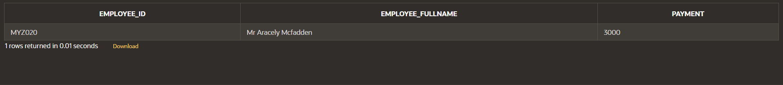

Querry 15 find who is the top excecutive in the company and who are his employees

declare

number_of_emp number;

v_record employees%rowtype;

cursor top_manager is

select count(employee_id)

from employees

where managers =

(

select employee_id

from employees

where managers is null

);

begin

open top_manager;

loop

fetch top_manager into number_of_emp;

exit when top_manager%notfound;

select * into v_record

from employees

where managers is null;

DBMS_OUTPUT.PUT_LINE('Manager '||v_record.employee_name||' '||v_record.employee_surname||' with ID '||v_record.employee_id||' has '||number_of_emp||' employees under him');

end loop;

close top_manager;

end;

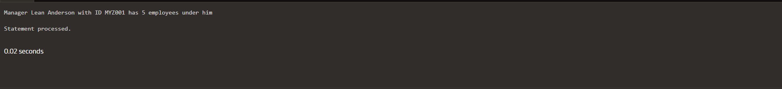

Querry 16 Display a report of employee id, employee full name and location for all employees who earn more than the average salary.

create or replace view salaries as (

select a.employee_id emp_id, a.employee_fullname fullname, a.location location, a.payment + (a.payment*(e.bonus/100)) salary

from assignments a

join employees e

on (a.employee_id = e.employee_id)

);

select *

from salaries

where salary >

(

select avg(salary)

from salaries

);

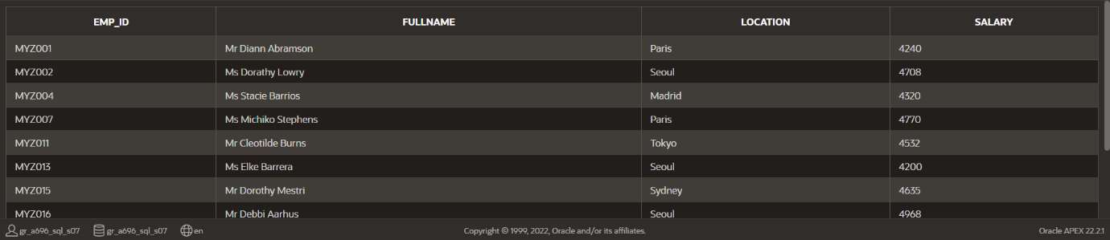

Querry 17. Modify the previous query to display information for employees who worked in assignments located in Paris.

select *

from salaries

where salary >

(

select avg(salary)

from salaries

)

and location in

(

select location

from salaries

where location = 'Paris'

);

Querry 18 Display Managers hierarchy

select level, lpad(' ',LEVEL+1, '$') || employee_surname "Employee",

employee_id, managers

from employees

start with managers is null

connect by prior employee_id = managers

order siblings by employee_surname;

Querry 19 Show every relation between all employees in a path format.

select sys_connect_by_path(employee_id||' '||employee_surname, '=>') Relations

from employees

start with managers is null

connect by prior employee_id = managers;

Querry 20 Show employees who aren't managers

select employee_id||' '||employee_surname "Employees who are not managers"

from employees

where connect_by_isleaf=1

start with managers is null

connect by prior employee_id=managers;

Querry 21 Calculate the profit per unit and display this information in the format:

"Product Name with ID:XXX of Collection name gives a profit of x% per unit"

declare

cursor find is

select *

from products;

profit number;

v_record products%rowtype;

begin

open find;

loop

fetch find into v_record;

profit :=v_record.price-v_record.cost;

exit when find%notfound;

dbms_output.put_line('Product '|| v_record.name ||' with ID: '|| v_record.product_id || ' of collection: ' || v_record.collection ||' gives a profit of '|| profit || '$ per unit.');

end loop;

close find;

end;

Querry 22 create a trigger which logs error codes and when they happened for orders table

create table error_log(

error_code number(6) not null,

error_message varchar2(4000),

date_of date not null

);

select *

from error_log

create or replace trigger error_catch

after insert on orders

for each row

declare

error_code number(6);

error_message varchar2(4000);

date_of date:=sysdate;

null_values exception;

prime_key exception;

begin

error_code:=sqlcode;

error_message:='Error: '||sqlerrm;

if :new.customer_id is null or :new.order_date is null or :new.pay_type is null or :new.order_status is null or:new.cost_firstshipment is null or :new.cost_secondshipment is null then

raise null_values;

end if;

exception

when null_values then

insert into error_log values(-20034,'Error: Null values not allowed',date_of);

dbms_output.put_line('Error: Null values not allowed');

when others then

insert into error_log values(error_code,error_message,date_of);

dbms_output.put_line(error_message);

end;

-- to test

insert into orders values ('OID231', 'CUS001', '31-Dec-2018', 'Bank Wire', 'Ready to ship', 482, null);

Querry 23 Calculate projected total costs

create or replace function shipping_costs

return number

is

v_first number :=0;

v_second number :=0;

v_cost number;

cursor my_cur is

select sum(cost_firstshipment), sum(cost_secondshipment)

from orders;

begin

open my_cur;

fetch my_cur into v_first,v_second;

close my_cur;

v_cost:=v_first +v_second;

return v_cost;

end shipping_costs;

create or replace function prod_cost

return number

is

costs number;

cursor prod_cur is

select sum(p.cost*i.total_quantity)

from products p join items i

using (product_id);

begin

open prod_cur;

fetch prod_cur into costs;

close prod_cur;

return costs;

end prod_cost;

create or replace function salary_cost

return number

is

costs number;

cursor sale_cur is

select sum(salary)

from salaries;

begin

open sale_cur;

fetch sale_cur into costs;

close sale_cur;

return costs;

end salary_cost;

-- final display

declare

expenses number;

begin

expenses := shipping_costs + prod_cost + salary_cost;

dbms_output.put_line('The total projected expenses of the company in salaries are ' || salary_cost || '$.');

dbms_output.put_line('The total projected expenses of the company in shipping are ' || shipping_costs || '$.');

dbms_output.put_line('The total projected expenses of the company in production are ' || prod_cost || '$.');

dbms_output.put_line('The total projected expenses of the company in production, shipping and salaries are ' || expenses || '$.');

end;

Further development suggestions

This application isn’t in its perfect state and some changes are :

1. To change the relationships between employees and assignments. This would mean that the 1-1 relationship that employees and assignments had would change to a M-N relationship. For this change to take place the company would need to update its freelancing hiring policies.
2. Some additional could be added to the tables, for example the expenses part of the business could also calculate the expenses that come from the materials used, a separate table that would go more into details about the payments of the employees.

The addition of these new data would make the database more complex, but the introduction to functions, procedure, triggers and censors can help us better analyze and work with this new data. Triggers are in particular very useful to us because with them we can implement the actual policies on what form the data must be added to the tables eliminating in this way human errors.

The user input functions are also a very good addition to the database because it can help us eventually create a database where we can create websites that use the information in these databases just like big stores and companies do in real life.